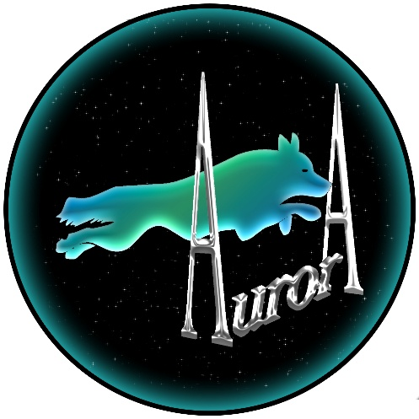

Invite you to a

BFA Sanctioned Limited Open Competition

at
Westmorland Showground
Cumbria LA7 7NH
on
Saturday and Sunday
4th & 5th July 2026

Grass

Entries limited to
60 teams block format

Closing date 5th June 2026

https://form.jotform.com/261366328357362

Singles, Pairs and Ring time will be offered to all teams if time and space allow after Open team entries received.
Show Rules and Regulations

- The Event Organiser(s) reserve the right to refuse entries and admission to the event of any persons not in good standing within the BFA.

- No person shall carry out punitive or harsh handling of a dog at the event.

- Bitches in season are not allowed near the show area. Mating of dogs is not allowed.

- A dog must be withdrawn from competition if it is:

- Suffering from infectious or contagious diseases.
- A danger to the safety of any person or animal.
- Likely to cause suffering to the dog if it continues to compete.

- It is the Team Captains responsibility to ensure the Team is available for their class and running order.

- No person shall impugn the decision of the head judge or judges.

- The organiser(s) reserve the right to make any alterations they deem necessary in the event of unforeseen circumstances.

- All dogs enter the event at their own risk and whilst every care will be taken, the Event Organiser(s) cannot accept responsibility for damage, injury, or loss however caused to dogs, persons or property whilst at the event.

- All owners/handlers must clear up after their dogs. Anyone failing to do so will be asked to leave the venue.

- If circumstances make it necessary to cancel the tournament the organisers reserve the right to defray expenses incurred by deducting such expenses from the entry fees received.

Current BFA Rules and Policies will apply throughout the Sanctioned Tournament.

