
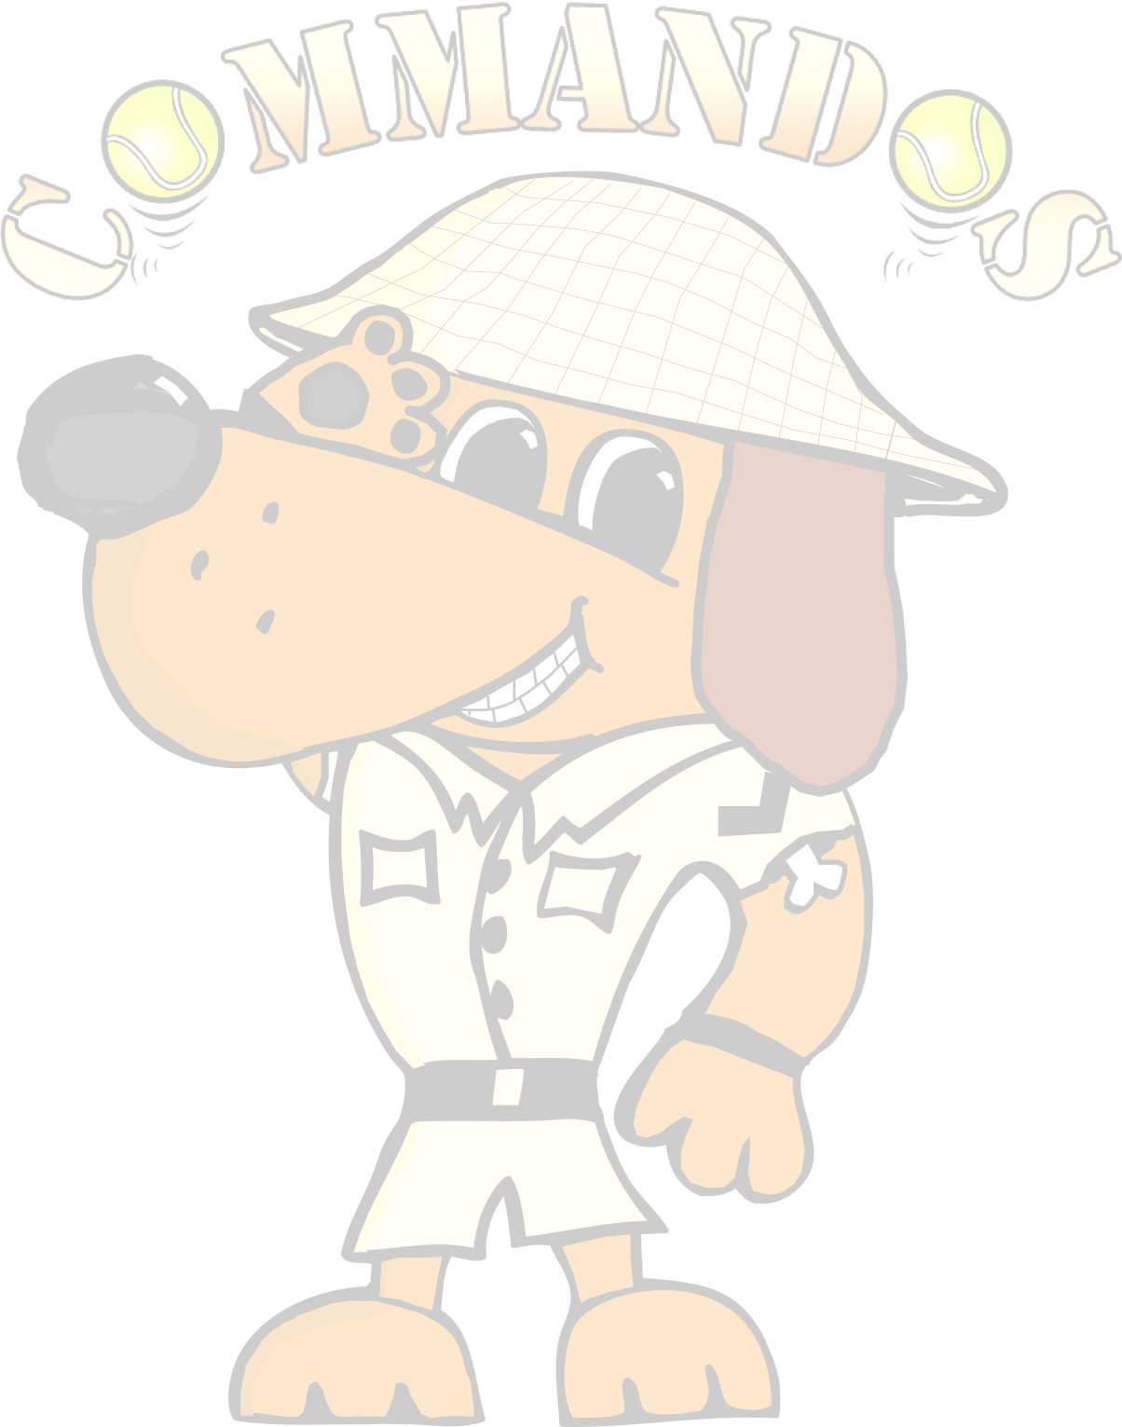
Present
Tootfest
British Flyball Association
Sanctioned Limited Open Tournament
54 teams- over 2 days
Starters Division Saturday only

to be held on 5th and 6th September 2026
at

Hillside Rural Activities Park (HRAP) Oaktree Bank Knayton, Thirsk YO7 4AX

Closing date for entries:

31st July 2026
Event is blocking format held outdoors on grass over the full weekend.

Starters Saturday Only (unsanctioned racing, not foundation)
- You will need 4 dogs to complete to receive a time for placing.
- Netting down centre of racing lanes & run-back area

Entries via google forms.
https://forms.gle/rgQwJe4mSVfUZGKv5

Tournament Organiser
Josephine Walker
9 Hendren Close
Darlington
County Durham
DL3 0JD
Tel: 07496539335 E-mail: commandostournamententry@gmail.com

For your entry to be valid we require the Team Name, the TRN, and the appropriate payment for each entry.

If we are oversubscribed at the 24-hour stage only valid entries will be included in the draw.
Payment either by cheque with entry or by bank transfer.
Cheques Payable to Commandos Flyball Teams.

Sort Code: 30-98-13
Account Number: 29698968

Declared times must be submitted, in writing or email at least 14 days before the tournament and must be at least ½ a second slower or ½ second faster than seed time.

All times, seed or declared, except Division 1, are subject to the division breakout rule.

Directions

Hillside Rural Activities Park is close to the A19 trunk road, between the villages of Borrowby and Knayton, North Yorkshire (grid reference SE 42918 88091). The address is Oaktree Bank South, Knayton, Thirsk YO7 4AX.

Please note that Sat. Nav. directs on postcode YO7 4AL or YO7 4AN (from south)
Click Here to View in Google Maps

Tournament Rules and Regulations
Team Captains are responsible for ensuring that all members of their teams and accompanying party are informed of the rules and regulations pertaining to this tournament.

1. The event organiser reserves the right to refuse entries and admission to the event of:
a) any team or person not in good standing with the BFA;
b) any team or person not complying with the request of the parking stewards, security personnel or event officials;
or
c) any team or person where the organiser has reasonable grounds to refuse entry or admission, including but not
limited to safety, welfare, conduct, safeguarding, venue requirements, or the proper running of the tournament.

2. No person shall carry out punitive or harsh handling of a dog at the event.

3. Bitches in season are not allowed near the show area. Mating of dogs at the event is not allowed.

4. A dog must be withdrawn from the competition if it is:
a) Suffering from any infectious or contagious disease.
b) A danger to the safety of any person or animal.
c) Likely to cause suffering to the dog if it continues to compete.

5. It is the team captain’s responsibility to ensure that the team is available for its races.

6. No person shall impugn the decision of the head judge or judges.

7. The organiser reserves the right to make any alterations deemed necessary in the event of unforeseen circumstances.

8. All dogs are entered in this event at their owner’s risk and, whilst every care will be taken, the event organiser, venue owners, landowners, and any associated parties cannot accept responsibility or liability for any damage, injury, loss,
or claim however caused to dogs, persons, or property whilst at the event. Furthermore, all participants agree that no legal action shall be taken against the venue owners, landowners, or event organisers in connection with the use of the site or participation in the tournament.

9. All owners/handlers must clear up after their dogs anywhere in the grounds. Anyone failing to do so will be asked to leave the venue.

10. Each team captain must ensure that all rubbish is removed or put in the skip before leaving the site.

11. All dogs are to be kept on a lead when not actually racing.

12. If circumstances make it necessary to cancel the tournament, the organisers reserve the right to defray expenses incurred by deducting such expenses from the entry fees received.

13. BFA rules and policies in effect at the date of the tournament and any site rules and policies will apply throughout the tournament.

14. All teams entering are expected to assist with ring party duties as requested by the tournament organiser
15. This tournament operates a strict speed limit of 5 mph which applies to all areas. Anyone breaching the speed limit may be asked to leave the event immediately. Vehicle movement must be restricted as much as possible around the competition area.

16. As per the BFA rules there will be no smoking or vaping within 15 feet of the ring. You are also asked to refrain from smoking or vaping during presentations and when sharing gazebos close to the ring.

17. There is a strict no alcohol policy in the ring.

