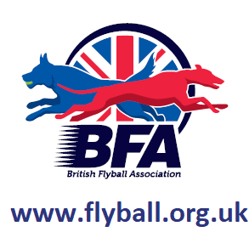
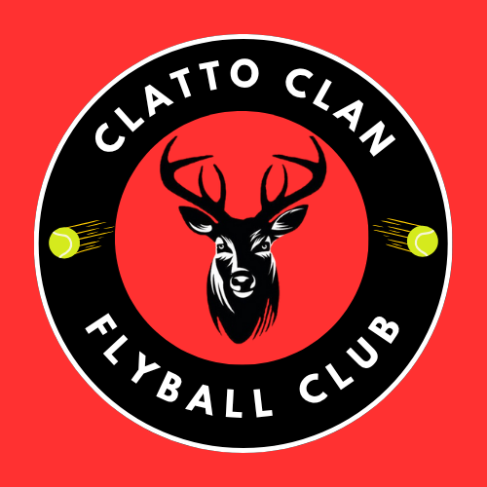

Sanctioned
Limited Open Tournament
(36 teams)
(5 Team Foundation Flyball Div)

CELEBRATING 25 YEARS OF SCOTTISH FLYBALL

Saturday 20th June & Sunday 21st June 2026

‘Tartan Tourney’
Errol Airfield
Errol
Perthshire
PH2 7TB

Entries to: Alison Moyes
Tel: 07572261126
Email: clattoclanflyballclub@outlook.com

Show Rules and Regulations
- (1) The Event Organiser(s) reserve the right to refuse entries and admission to the event of any persons not in good standing within the BFA.
- (2) No person shall carry out punitive or harsh handling of a dog at the event.
- (3) Bitches in season are not allowed near the show area. Mating of dogs is not allowed.
- (4) A dog must be withdrawn from competition if it is:
- (a) Suffering from infectious or contagious diseases.
- (b) A danger to the safety of any person or animal.
- (c) Likely to cause suffering to the dog if it continues to compete.
- (5) It is the Teams Captain’s responsibility to ensure the team is available for their division and running order.
- (6) The organiser(s) reserve the right to make any alterations they deem
- necessary in the event of unforeseen circumstances.
- (7) All dogs enter the event at their own risk and whilst every care will be taken, the Event Organiser(s) cannot accept responsibility for damage, injury, or loss however caused to dogs, persons or property whilst at the event.
- (8) All owners/handlers must clear up after their dogs. Anyone failing to do so will be asked to leave the venue.
- (9) BFA Rules and Policies will apply throughout the Sanctioned Tournament.
- (10) In the event of a 3-way tie winner will be decided on times. In a 2 way tie the winner is who beat who.
- (11) This is an OUTDOOR tournament, In the event of the tournament being cancelled, the organisers reserve the right to defray expenses incurred by deducting such expenses from the entry fees received
- THE TOURNAMENT WILL BE RUN ON GRASS
Saturday 20th June and Sunday 21st June 2026

- Entry Fee
  - Open £50 per Team
  - Foundation Flyball £40 per Team
- Declared times due 14 days before the Tournament.
- Team break-out time is quarter of a second faster than declared time
- All times, seed or declared, except Div. 1, are subject to the division break-out rule.

- TEAM NAME BFA No.
- 1
- 2:
- 3:
- 4:
- 5:
- 6:
- Foundation Flyball Team Name(s)

- Team Captain :
- BFA No:
- Address :
- Telephone :
- Email :

- Name of anyone who is a Head Judge, Qualified Judge, Provisional Judge, Qualified Measurer or Provisional Measurer (HJ, QJ, PJ, QM, PM):

- Number of Teams entered at £50 per team:
- Foundation Flyball Teams entered at £40 per team:
  - Please ensure all non-BFA members pre-register and receive PR code.
- Camping Pitches required at £10 per pitch per night:
- Total £

BACS payments to:
- Clatto Clan Community Flyball Club
- Acc No: 60769432
- Sort code: 54-41-51

