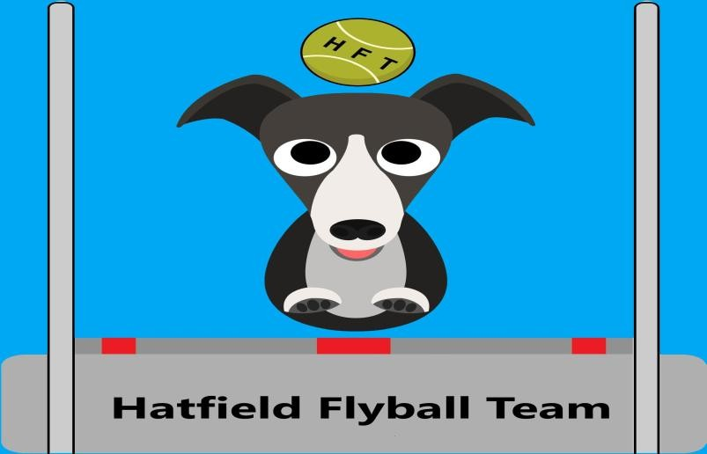
Hatfield Hit & Run
BFA Sanctioned Limited (80 Teams)
Flyball Tournament
On
23/24th May 2026
Limited Multibreed (32 teams )
25th May 2026
Closing date 21st April 2026
At Haxey Quays Caravan Park
Haxey Road Misterton
Doncaster DN104BA
Lynn Neal – 07789376247
Email lynn19631@hotmail.co.uk Hatfield Hit & Run
Declared times must be submitted in writing (or email) at least 14 days before the Tournament and must be at least half a second faster or slower than seed time. (BFA rule 4.3)
Team break-out time is quarter of a second faster than declared time (A3.11) . All times, seed or declared, except Div 1, are subject to the division break-out rule.
Closing Date for Entries 21st April 2026
 | BFA TEAM NAME | 0pen or Foundation |  |  | BFA TRN
1
2
3
4
5
6
7
8
Captains Name: |  |  | Address
Tel: |  |  | Address
Email: |  |  | Address
If you are able to provide judges for the show, please advise names and indicate whether  Head, Qualified, or Provisional Judge or  Measuring Official. Thank you |  | Judges:
Team Entry at £45 per Team |  |  |  | £
No Entries to be accepted without payment Please complete & return entries to:
Hatfield Flyball Clubs Lynn Neal
Sort Code 40-19-20 40, Mile End Avenue
Account Number 74187318 Hatfield
Doncaster
DN7 6AW

The two minute rule will apply throughout the tournament.

Camping
Camping Names | No. Nights | Total £15 per night
1 |  | £ | C/T/M
2 |  | £ | C/T/M
3 |  | £ | C/T/M
4 |  | £ | C/T/M
5 |  | £ | C/T/M
6 |  | £ | C/T/M
7 |  | £ | C/T/M
8 |  | £ | C/T/M
9 |  | £ | C/T/M
10 |  | £ | C/T/M
please circle whether its: |  |  | Total
C-Caravan |  |  | £
T-Tent
M-Motorhome

SHOW RULES AND REGULATIONS
Please Note: Team Captains/Managers are responsible for ensuring that all members of their teams and accompanying party are informed of the rules and regulations pertaining to this tournament.
1. The event organiser reserves the right to refuse entries and admission to the event of
a) any person not in good standing with the BFA or b) any person not complying with the request of the parking stewards of security personnel.
- No person shall carry out punitive or harsh handling of a dog at the event.
- Bitches in season are not allowed near the show area. Mating of dogs at the event is not allowed.
- A dog must be withdrawn from the competition is if is: a) Suffering from any infectious or contagious disease. b) A danger to the safety or any person or animal. c) Likely to cause suffering to the dog if it continues to compete.
- It is the team captain’s responsibility to ensure that the team is available for its races.
- No person shall impugn the decision of the head judge or judges.
- The organizer reserves the right to make any alterations deemed necessary in the event of unforeseen circumstances.
- All dogs are entered in the event at their owners risk and, whilst every care will be taken, the event organizer cannot accept responsibility for damage, injury or loss however caused to dogs, persons or property whilst at the event.
- All owners/handlers must clear up after their dogs anywhere in the grounds. Anyone failing to do so will be asked to leave the venue.
- Each team captain must ensure that all rubbish is removed or put in the skip before leaving the site.
- All dogs are to be kept on a lead when not actually racing.
- If circumstances make it necessary to cancel the tournament, the organisers reserve the right to defray expenses incurred by deducting such expenses from the entry fees received.
- Current BFA rules and Policies will apply throughout the tournament.
- All teams entering are expected to assist with ring party duties as requested by the tournament organizer.

