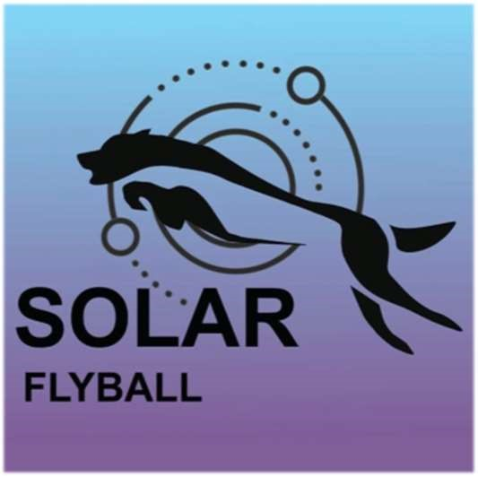
SOLAR FLYBALL TEAM
BRITISH FLYBALL ASSOCIATION LIMITED OPEN COMPETITION
Hook Farm, Mundon Road, Maldon, CM9 6PN
11th – 12th July 2026
Closing date: 12th June 2025
Foundation on Saturday & Sunday dependent on entries Limited open to 48 teams - Head judge: Jason Baker
Contact: Lincoln Brookes– 07711 120050

*******EMAIL ENTRIES ONLY PLEASE******* you will receive a confirmation of entry:
solarflyballteam@gmail.com
*Camping available from 15:00 on Friday 10th July.*
Camping is STRICTLY LIMITED and must be booked in advance. Camping will be marked out (standard 10m x 8m pitch), and you will be directed to your area upon arrival. We cannot guarantee we can accommodate late bookings.
Porta loos on site.
Please take you rubbish home where possible (but a skip will be available)
This is a registered camping site so please respect the grass.
Food can be ordered and delivered by various takeaway restaurants, however there will be a catering van attending on Friday evening, Saturday and Sunday all day.
Local pub – 2 mins drive - White Horse, CM9 6PB (01621 740276).
Local supermarkets within 2 miles.
Ice cream van attending Friday, Saturday and Sunday afternoon.

ENTRY FORM – Limited Open
Declared times must be submitted by email at least 14 days before the tournament as per the BFA rules. All times, seed or declared, except Div 1, are subject to the Division break-out rule.
Team Name Team Number
(1)
............................................. ............................
(2)
............................................ .............................
(3)
......................................... ................................
(4)
.......................................... ...............................
(5)
......................................................................... ................................
(6)
......................................................................... ................................
Team Captain: ..............................................................................
Telephone: ....................................................................................
E-Mail: ....................................................................................
Teams entered ......... at £50.00 per team = £ ...............
Qualified Judges: | Provisional Judges: | MO’s
______________________ | ______________________ | ____________________
Camping (£12.00 per unit per night).
Please book camping in advance, as pitches will be marked out accordingly. Late bookings may not be able to be accommodated.
Friday………... Saturday………. Sunday (by private arrangement with campsite owner) ………...
Summary:
Open Teams: £.................. Foundation Teams: £.................. Camping: £.................. TOTAL: £..................
Bank payments only to:
Account Name: Solar Flyball
Sort Code: 20-19-97
Account Number: 33645630
****PLEASE ENSURE CAMPING IS PAID FOR IN ADVANCE****
Show Rules and Regulations
- The Event Organiser(s) reserve the right to refuse entries and admission to the event of any persons not in good standing within the BFA.
- No person shall carry out punitive or harsh handling of a dog at the event.
- Bitches in season are not allowed near the show area. Mating of dogs is not allowed.
- A dog must be withdrawn from competition if it is :
- Suffering from infectious or contagious diseases.
- A danger to the safety of any person or animal.
- Likely to cause suffering to the dog if it continues to compete.
- It is the Team Captains responsibility to ensure the Team is available for their class and running order.
- No person shall impugn the decision of the head judge or judges.
- The organiser(s) reserve the right to make any alterations they deem necessary in the event of unforeseen circumstances.
- All dogs enter the event at their own risk and whilst every care will be taken, the Event Organiser(s) cannot accept responsibility for damage, injury, or loss however caused to dogs, persons or property whilst at the event.
- All owners/handlers must clear up after their dogs. Anyone failing to do so will be asked to leave the venue.
- If circumstances make it necessary to cancel the tournament the organisers reserve the right to defray expenses incurred by deducting such expenses from the entry fees received.
Current BFA Rules and Policies will apply throughout the Sanctioned Tournament.
Camping Regulations:
  - Camping is limited, please be considerate when setting up.
  - All vehicles should keep to 5mph on the venue. Please keep driving during the tournament to a minimum.
  - Please ensure generators are switched off between 10pm and 7am.
  - Barbeques are allowed but please ensure they are off the ground, take extra care and ensure there is a water bucket to hand.
  - Please pick up dog waste and litter and put them in the correct bins.
STRICTLY NO DOGS ALLOWED ON THE FARM FIELDS SURROUNDING AT ANY TIME
