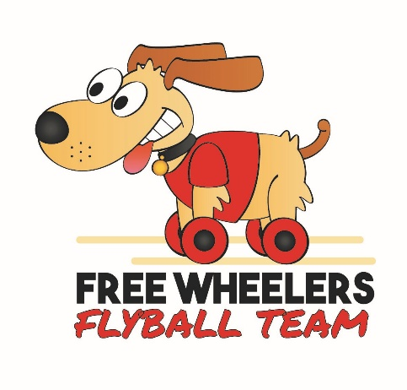

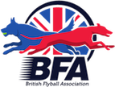

Free Wheelers Flyball Team, British Flyball Association
Sanctioned Limited Open
Tournament (48 Teams)
At Wetherby Racecourse, Wetherby LS22 5EJ

On Saturday 26th & Sunday 27th September 2026
Over 2 days

For enquiries only, please email freewheelersflyball@hotmail.com or contact Claire Hardy on 07456 883555

Tournament Organiser – Claire Hardy
48 Station Road, Hambleton, Selby, North Yorkshire YO8 9HY

Please complete the following Entry Form

https://form.jotform.com/262155594131051

Closing date 26th August 20261

Entry Fee £45 per Open Team
Foundation will be run if entries allow (£8 per dog, £32 max)

Declared times must be submitted in writing (or email) at least 14 days before the
Tournament and must be at least one half second faster or half a second slower than seed time. (BFA rule A1:4.3)
All times, except Div 1, are subject to the division break-out rule.

Payment either by cheque with entry or by bank transfer.
Cheques Payable to Freewheelers Flyball Club
Bank transfer, please use your team name as reference:-
Freewheelers Flyball Club
Account Number – 19775260 Sort Code – 77-71-61

Tournament Rules and Regulations

Team Captains are responsible for ensuring that all members of their teams and accompanying party are informed of the rules and regulations pertaining to this tournament.

1. The event organiser reserves the right to refuse entries and admission to the event of:
a) any team or person not in good standing with the BFA;
b) any team or person not complying with the request of the parking stewards, security personnel or event officials;
or
c) any team or person where the organiser has reasonable grounds to refuse entry or admission, including but not limited to safety, welfare, conduct, safeguarding, venue requirements, or the proper running of the tournament.

2. No person shall carry out punitive or harsh handling of a dog at the event.

3. Bitches in season are not allowed near the show area. Mating of dogs at the event is not allowed.

4. A dog must be withdrawn from the competition if it is:
a) Suffering from any infectious or contagious disease.
b) A danger to the safety of any person or animal.
c) Likely to cause suffering to the dog if it continues to compete.

5. It is the team captain’s responsibility to ensure that the team is available for its races.

6. No person shall impugn the decision of the head judge or judges.

7. The organiser reserves the right to make any alterations deemed necessary in the event of unforeseen circumstances.

8. All dogs are entered in this event at their owner’s risk and, whilst every care will be taken, the event organiser, venue owners, landowners, and any associated parties cannot accept responsibility or liability for any damage, injury, loss, or claim however caused to dogs, persons, or property whilst at the event. Furthermore, all participants agree that no
legal action shall be taken against the venue owners, landowners, or event organisers in connection with the use of the site or participation in the tournament.

9. All owners/handlers must clear up after their dogs anywhere in the grounds. Anyone failing to do so will be asked to leave the venue.

10. Each team captain must ensure that all rubbish is removed or put in the skip before leaving the site.

11. All dogs are to be kept on a lead when not actually racing.

12. If circumstances make it necessary to cancel the tournament, the organisers reserve the right to defray expenses incurred by deducting such expenses from the entry fees received.

13. BFA rules and policies in effect at the date of the tournament and any site rules and policies will apply throughout the Tournament.

14. All teams entering are expected to assist with ring party duties as requested by the tournament organiser

15. This tournament operates a strict speed limit of 5 mph which applies to all areas. Anyone breaching the speed limit may be asked to leave the event immediately. Vehicle movement must be restricted as much as possible around the
competition area.

16. As per the BFA rules there will be no smoking or vaping within 15 feet of the ring. You are also asked to refrain from smoking or vaping during presentations and when sharing gazebos close to the ring.
17. There is a strict no alcohol policy in the ring.

