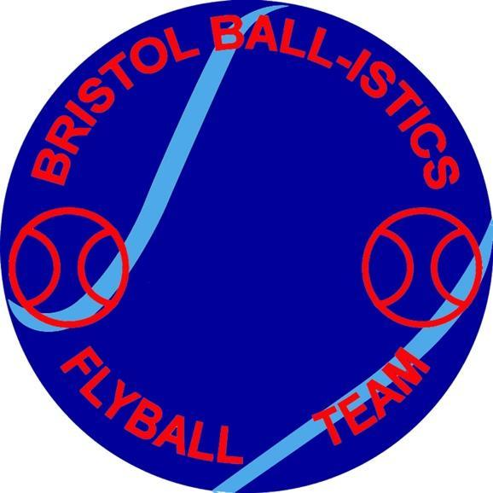

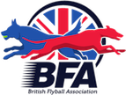

Inviting you to our Show
British Flyball Association
Limited Open Competition

West Woodlands Showground
Bunns Lane, Frome
Somerset, BA11 5ES
What3words ///direction.veiws.evaporate

On 27th & 28th June 2026

Open Show Over 2 Days
Including Foundations.
Camping Available Friday & Saturday Night
£12 per unit per night.

Entries via Google form
https://forms.gle/P21ZyTVvsDzF9KmDA
You will have a copy of your entry emailed to you.

All Enquires please email to
Bristolballisticsclub@gmail.com

Show Rules and Regulations

(1) The Tournament Organiser(s) reserve the right to refuse entries and admission to
the event of any persons not in good standing within the BFA.

(2) No person shall carry out punitive or harsh handling of a dog at the event.

(3) Bitches in season are not allowed near the tournament area. Mating of dogs is not allowed.

(4) A dog must be withdrawn from competition if it is:
(A) Suffering from infectious or contagious diseases.
(B) A danger to the safety of any person or animal.
(C) Likely to cause suffering to the dog if it continues to compete.

(5) It is the Team Captain’s responsibility to ensure the Team is available for their
Division and running order.

(6) The Organiser(s) reserve the right to make any alterations they deem necessary in
the event of unforeseen circumstances.

(7) If circumstances make it necessary to cancel the Tournament, the Organiser(s)
reserve the right to defray expenses incurred by deducting such expenses from the
entry fees received.

(8) All dogs enter the event at their own risk and whilst every care will be taken, the
Tournament Organiser(s) cannot accept responsibility for damage, injury, or loss
however caused to dogs, persons or property whilst at the event.

(9) All owners/handlers must clear up after their dogs. Anyone failing to do so will be
asked to leave the venue.

(10) Current BFA Rules and Policies will apply throughout the Sanctioned Tournament.

(11) No person shall impugn the decision of the head judge or judges.

Current BFA Rules and Policies will Apply throughout the Sanctioned Tournament.

